Ideation Phase Brainstorm & Idea Prioritization

Template
Date | 28 OCT 2025
Team ID | NM2025TMID05124
Project Name | Laptop Request Catalog Item

Laptop Request Catalog Items Template

This guided project demonstrates how to standardize and secure the process of requesting laptops through a catalog system. The workflow starts with the creation of test catalog items (laptop models and bundles) and involves assigning requests to users for validation.

A business rule is established: requests can only be submitted if the selected laptop item is available in the catalog. This prevents accidental or erroneous requests for discontinued or out-of-stock items, ensuring fulfillment teams process only valid requests. By enforcing these rules, data integrity is preserved and accidental duplicate or unsupported requests are avoided.

The workflow includes test scenarios to validate system behavior:

First, a test request is performed for a catalog item that is active and available, confirming approval and successful processing.

Next, an attempt is made to request a laptop that is marked unavailable in the catalog, verifying the system blocks the submission, delivers a clear error message, and maintains accurate request records.

Step-1: Team Gathering, Collaboration and Select the Problem Statement:
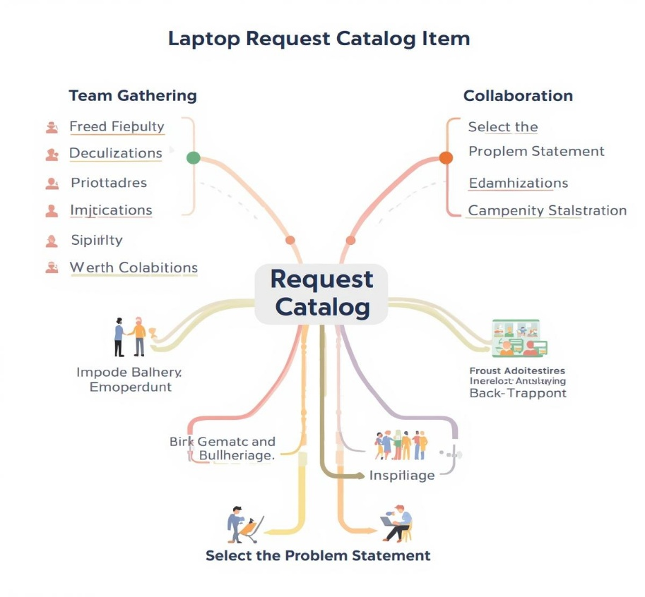

Step-2: Brainstorm, Idea Listing and Grouping:
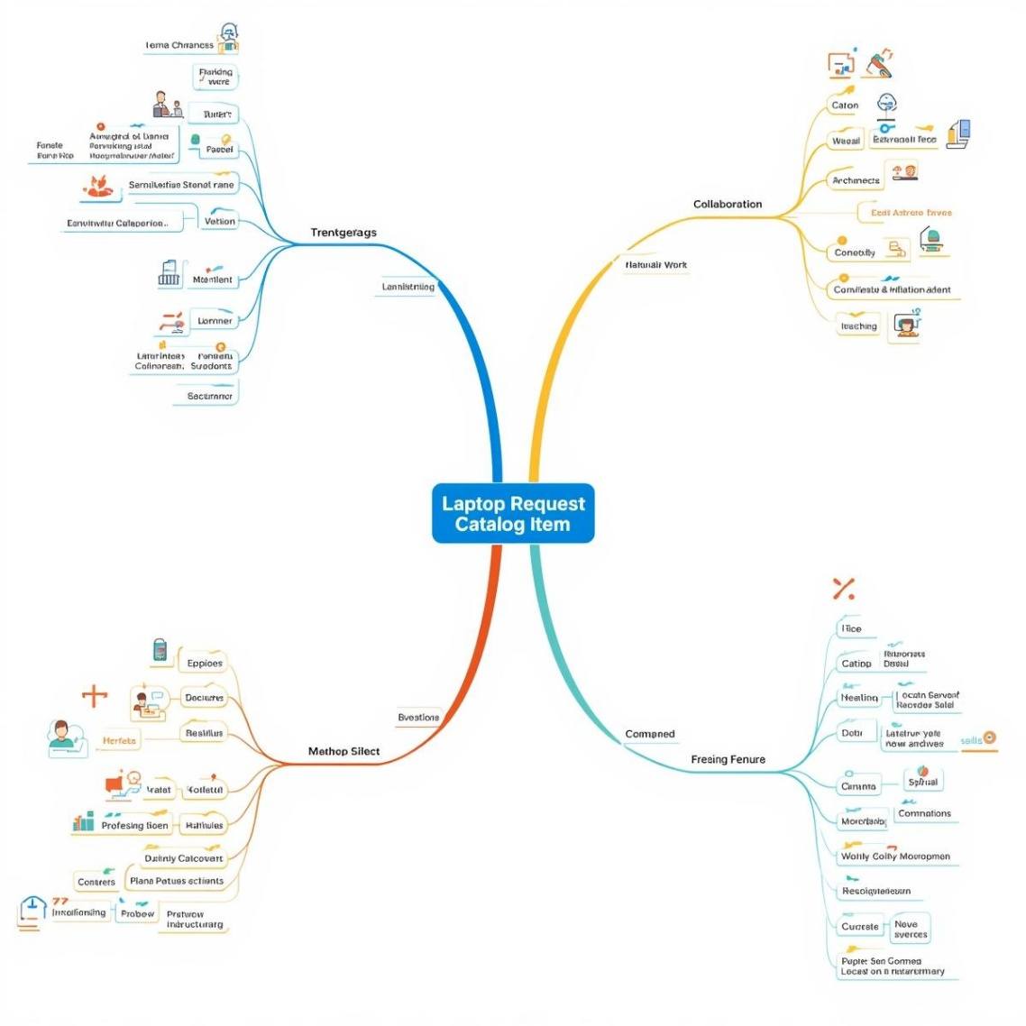
Fig2: Image that describes the work done by teammates.
⬛✓⬛ Brainstorm:
Team members discuss and share ideas on how to improve the laptop request process, focusing on user experience, approval efficiency, and IT resource management.
⬛✓⬛ Idea Listing:
All proposed features and suggestions are documented, including model comparison options, automated approval workflows, and integration with HR systems.
✓⬛ Grouping:

Similar ideas are categorized into functional areas such as user interface design, data automation, and reporting tools to identify key priorities and streamline development

⬛✓ Action Planning:
Selected ideas are converted into actionable steps—assigning roles for catalog design, system integration, and testing, along with clear timelines for implementation and review.

Step-3: Idea Prioritization:

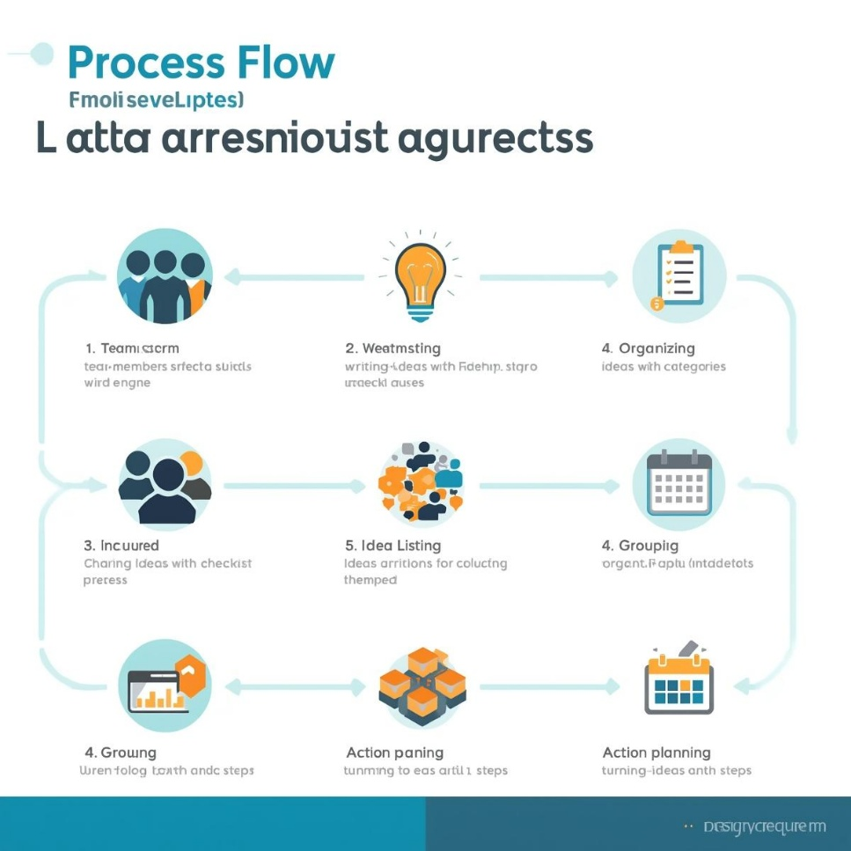
Fig3: Image of steps to prevent user deletion.

Idea Polarization for Laptop Request Catalog Item

Idea polarization helps divide the laptop request catalog project into clear, manageable components. The main goal is to ensure that every laptop request is processed efficiently, transparently, and securely. This approach maintains data accuracy and accountability throughout the approval and allocation workflow.

By polarizing ideas, the team can separate catalog management tasks—such as model listing, request tracking, and approval routing—from administrative functions like inventory updates and reporting. This distinction enhances focus and simplifies execution.

It also emphasizes the importance of controlled access, ensuring that only authorized personnel can approve or modify laptop requests. Each stage—from request submission to final delivery—becomes easier to plan, monitor, and optimize.

Visual tools like flowcharts and process diagrams can further clarify the workflow, helping teams communicate effectively and align on responsibilities. Overall, idea polarization strengthens project clarity, improves coordination, and supports smooth implementation of the laptop request catalog system.

